High Level Design Documents

# Concept One – Neon Orange

## Elevator Pitch

Neon Orange is a game where you cruise through the city on a mix between a lightsaber and a skateboard. With exhilarating fast-paced riding and tense precision platforming, you will manoeuvre through many obstacles and challenges.

## Features/Experiences

Retro Neon Aesthetic

* Art, Music, and gameplay all in sync
* Fully immerse the player

Responsive Controls

* Key to the platforming genre
* Makes the game fair and about skill

Fast and Fluid Gameplay

* Key to the core experience
* Keeps the player engaged with gameplay that isn’t too hard for mid-core gamers, but also appeals to core gamer’s need for a tough challenge

## Key Systems/Designs

Movement

* Aerial direction movement
* Acceleration/deceleration
* Fall off board
* Wall jumping

Boosting

* Accelerate for limited time
* Fills from boost pick-ups

Obstacles

* Crates to jump over
* Alleyways to wall jump
* Break through specific walls

## Markets/Platforms

Target market includes core gamers, mid-core, and casual because every level has challenging extra objectives that you can complete for special rewards, yet the base gameplay is very simple to grasp. The game would be compatible with phones so a casual gamer could play anywhere when they have time.

The game would be released on major consoles, PC marketplaces, and phones.

## Story Premise

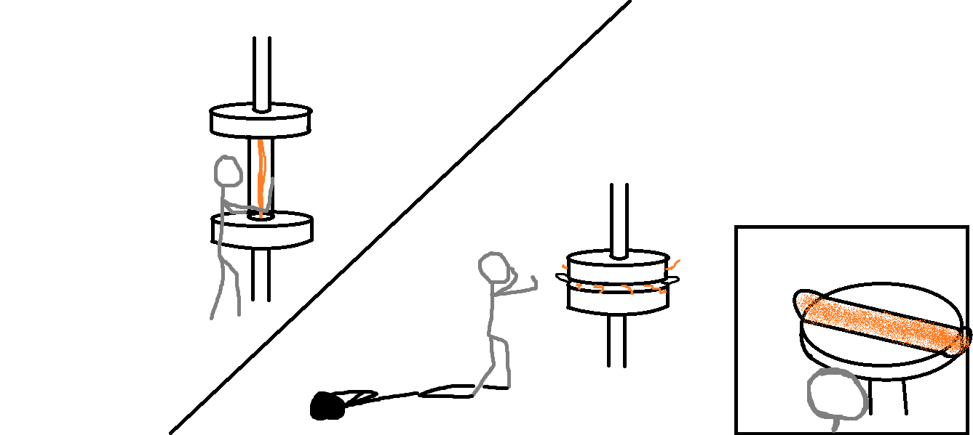You are a scientist employed by TheMan (Theoretical Manufacturing) who is fed up with the company’s immoral business practises. Their mountain manufacturing plant streams toxic orange goo down into the city below and the mayor has been paid off. In hopes of sabotaging the city-based research facility where you work, you try to destroy the highly experimental graviton laser technology.

However, this doesn’t go exactly as planned when the containment device is condensed into a board-like shape, sending bolts of condensed gravity everywhere. The workshop is wrecked and there’s orange goo flooding the room, so you jump to safety on the containment platform realising the newly formed board is destroying the goo around it. Armed with the laser board you aim to reverse all the damage TheMan has done by getting rid of the toxic goo flowing through the city.

## Experience Examples

# Concept Two – Obvious Office

## Elevator Pitch

Obvious Office is a first-person puzzle game in which the hazards of the game are not obvious. There are invisible mines hidden everywhere and it’s up to you to evacuate the office. The only way to discover these dangers is to use the objects around you such as coffee cups and staplers, because you must escape the office building alive.

## Features/Experiences

Tactical office-junk action

* Use the mundane environment to your advantage
* Plan how to use the limited items

Suspense driven gameplay

* Hidden danger all around you
* Every step could be your last

## Key Systems/Designs

Movement

* Walk and run speeds
* Normal and running jump distances
* Precise, not floaty

Mines

* Not visible
* Destroy anything in radius

Objects

* Only one can be picked up at a time
* Can be thrown a set distance

Office

* Many floors
* Level end is the elevator

Employees

* Hiding/cowering around the workplace
* Must collect them all before leaving level

## Markets/Platforms

Pc and console

## Story Premise

You are a superhero with a secret identity. Your arch nemesis found out where you work and laid traps all around your workplace, so you must save all your scared co-workers and avoid all the traps without showing your powers. Your excuse for guiding everyone out is that you are the trained evacuation leader.